**Exp No:22**

**Date:**

**DATABASECONNECTIVITYUSINGPHP AND MYSQL**

**AIM:**

To connect the MySQL using PHP and to execute the CREATE, INSERT, DELETE, UPDATE and SELECT command in MySQL

**OUTPUT:**

creation of database and emp table

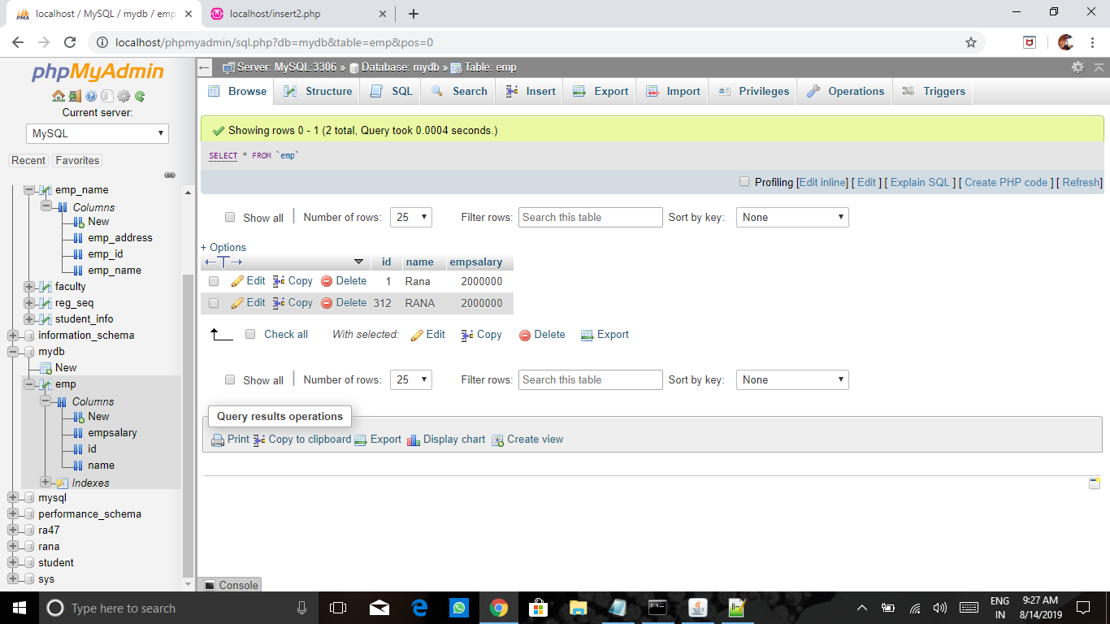

deletion:

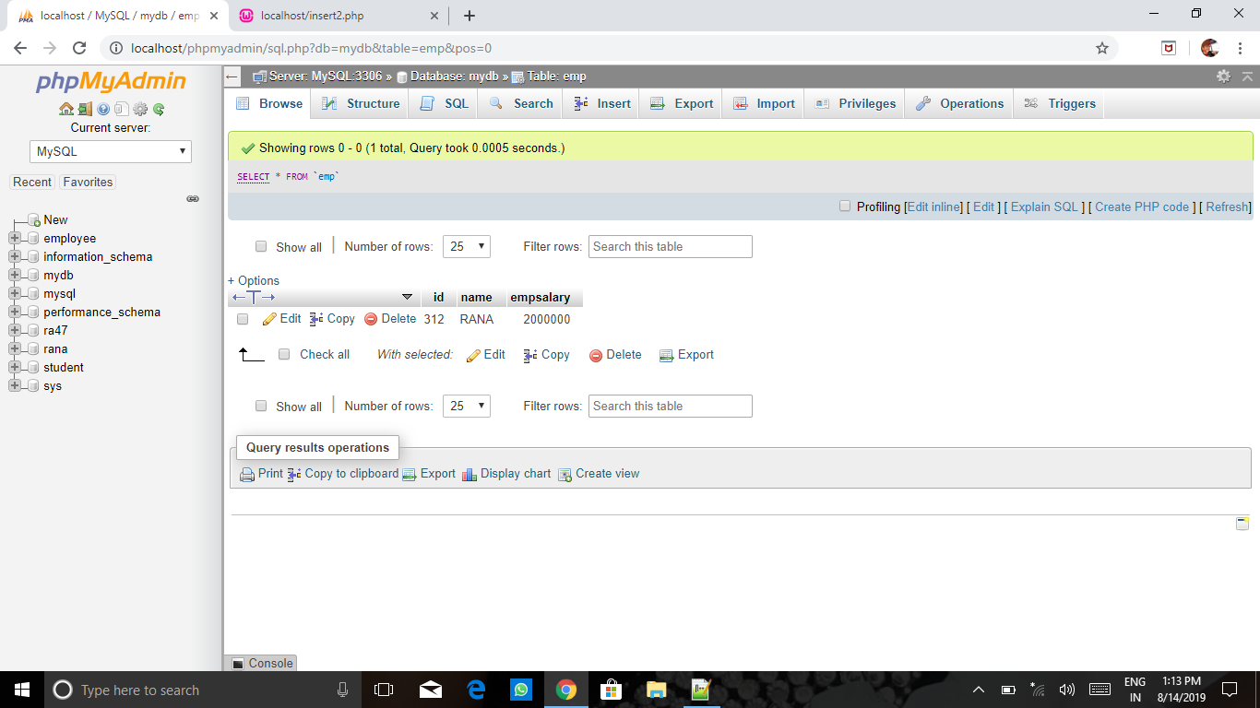

updation:

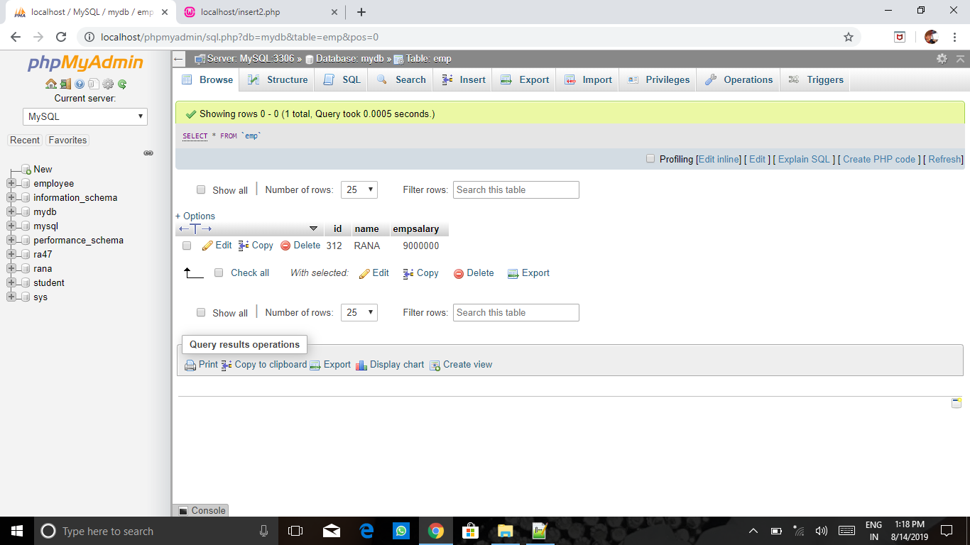

**RESULT:**

Thus the MySQLis connected using PHP and executed the CREATE, INSERT, DELETE, UPDATE and SELECT command in MySQL.